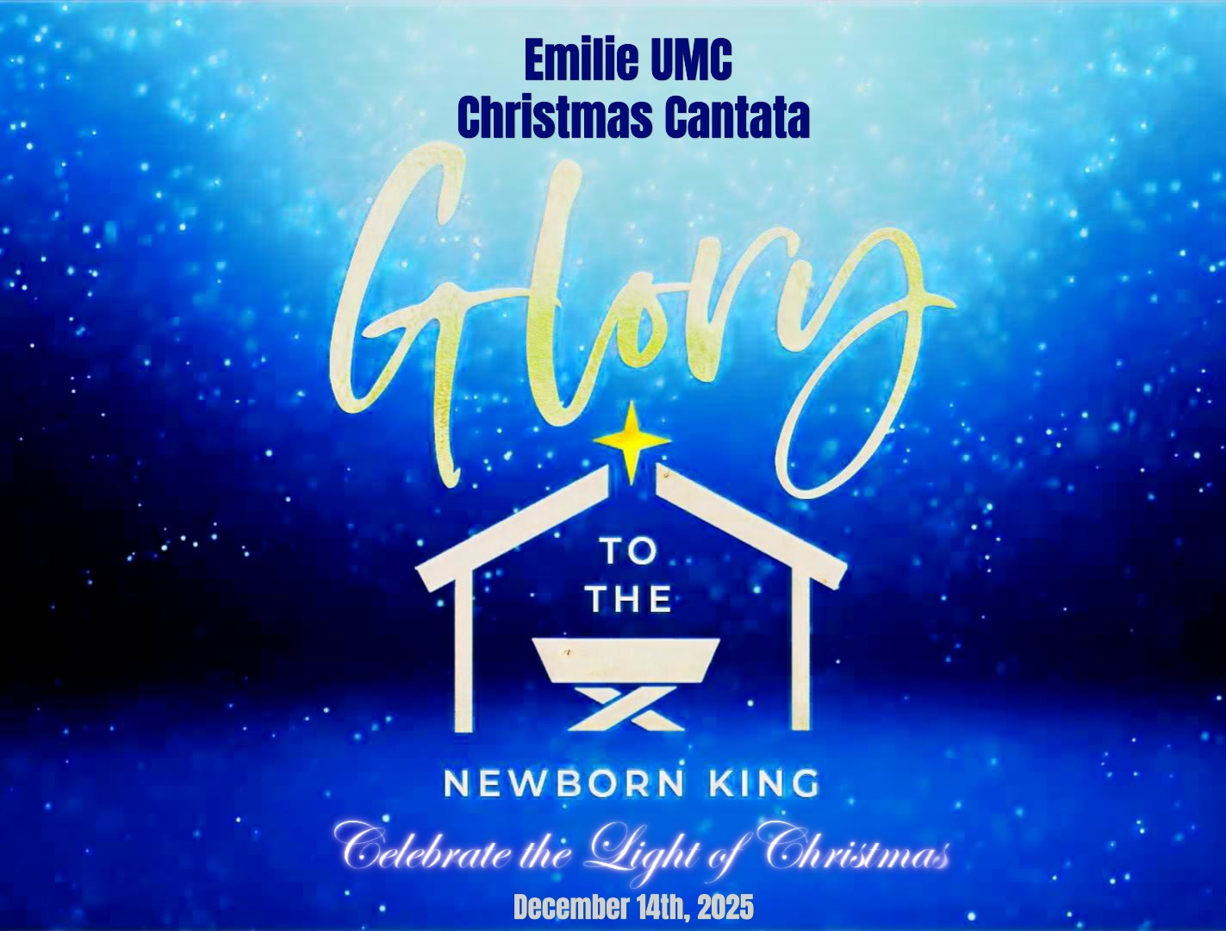

7300 New Falls Road, Levittown PA 19055
Phone: 215-945-5502
E-mail: office@emilieumc.com
Website: www.emilieumc.com

Christmas Cantata
Glory To the Newborn King
By Lloyd Larson

Prelude & Call to Worship Come, Joy of Every Longing Heart
Sanctuary Choir

Pastor Stacey: Longing…yearning…anticipating a better season, a more hopeful outcome, a brighter day…all of us have experienced those moments.
Liturgist: For Israel, that new day could not arrive soon enough. With a history of bondage, years of war, and uncertainty, they longed for the words of the prophets to become reality in their lifetime: that a Messiah would come to rescue them from their anguish and pain.
Pastor Stacey: The children of Israel experienced the darkest of long nights as they awaited the promised Messiah. They longed for a king who, as King David had described, would rule out of reverence for God’ one who would dawn on them like the morning light, like the sun shining forth on a cloudless morning.
Liturgist: The prophets had said that one day the Root of Jesse would stand as a banner for all people. The nations would seek Him and His place of rest would be glorious.
Pastor Stacey: It was the prophet Isaiah who said that the wilderness and the dry lands would be made glad; that they would blossom like a rose with abundant joy and singing.
Liturgist: A voice cries out: “In the wilderness prepare the way of the Lord; make straight in the desert a highway for our God. Every valley shall be lifted up and every mountain and hill be made low; the uneven ground shall become level, and the rough places a plain.
Pastor Stacey: And the glory of the Lord shall be revealed, and all flesh shall see it together, for the mouth of the Lord has spoken.”
Liturgist: The people walking in darkness have seen a great light on those living in the land of the shadow of death a light has dawned.
All: These were words of hope, words of promise. They were the lifeline to which the people of God clung as they awaited the promised Messiah’s arrival, a beacon of hope and light in a dark and dreary land.

*Opening Hymn I want to walk as a child of the Light (vs. 1,3)
UMH #206

1

Lighting of the Advent Wreath Susan Lowe

Liturgist: The prophets of Old Testament Israel carried dual assignments. Sometimes they were the bearers of difficult, even harsh, messages from God as he sought to reconcile relationships with His people. Other times, though, they were called to bring good news of comfort and hope, joy and peace.
Pastor Stacey: Comfort, comfort my people says your God. Speak tenderly to Jerusalem, and cry to her that her warfare is ended, that her iniquity is pardoned, that she has received from the Lord’s hand double blessings for all her sins.
Liturgist: For to us a Child is born, to us a Son is given; and the government shall be upon His shoulder, and His name shall be called Wonderful Counselor, Mighty God, Everlasting Father, the Prince of Peace.
Pastor Stacey: Of the increase of His government and of peace there will be no end, on the throne of David and over His kingdom, to establish it and to uphold it with justice and with righteousness from this time forth and forevermore
Liturgist: The zeal of the Lord of host will do this. (Light the candle)

Comfort and Peace Sanctuary Choir

Narration 3

Pastor Stacey: the prophet Isaiah had foretold hundreds of years before the Messiah’s arrival that a young maiden would give birth to a son, and that He was to be called Emmanuel (which means God with us).
Liturgist: Another prophet, Michah, had told Israel that this Messiah would be born in a remote village: You, Bethlehem, though you are small among the clans Hudah, out of you will come One who will be ruler over Israel.
Pastor Stacey: In God’s perfect timing, the words of the prophets became reality. A young maiden named Mary was engaged to a man named Joseph.
Liturgist: God had told Mary through the angel Gabriel that she would conceive this holy child, the Son of God. Joseph, too, had received confirmation from God that he was to be the earthly father of this heavenly King.

2
Pastor Stacey: In those days, a decree was issued by Caesar Augustus that a census was to be taken of the entire Roman world. Everyone was to return to their hometown to register.
Liturgist: Joseph was from Bethlehem, the town of David, because he belonged to the house and line of King David. So, he and Mary made their way to Bethlehem.
Pastor Stacey: It was while they were in Bethlehem that the time came for Jesus – the long-awaited Messiah, Love’s pure and perfect light – to be born.

Bethlehem, O Bethlehem Sanctuary Choir

Narration 4

Liturgist: Jesus, the King Messiah, eternal gift of God, had been born in the most unlikely of places and in the most unlikely of ways.
Pastor Stacey: The gospel of Luke says that after Mary gave birth to her firstborn son, she wrapped Him in swaddling cloths and laid Him in a manger, because there has been no place for them to stay.
Liturgist: And in that same region, there were shepherds out in the field keeping watch over their flock by night. It was just an ordinary night for ordinary shepherds and their sheep.
Pastor Stacey: Out of the darkness an angel of the Lord appeared to them, and the glory of the Lord shone around them. They were filled with great fear!
Liturgist: But the angel said to them: “Do not be afraid. I bring good news of great joy for you and all people! Today in the town of David a Savior has been born. He is Christ the Lord. This will be a sign to you: You will find a baby wrapped in cloths and lying in a manger.”
Pastor Stacey: Suddenly a great company of the heavenly host appeared with the angel praising God and saying, “Glory to God in the highest, and on earth peace among all people!”
Liturgist: When the angels had left them and returned to heaven, the shepherds said to one another, “Let us go to Bethlehem and see this thing that the Lord has told us about.”

All: So, they went with haste and made their way to Bethlehem in search of the newborn King so they might offer him their homage.

Receiving God’s Tithes

3
Offertory The Shepherd’s Noel Sanctuary Choir

Narration 5

Liturgist: The shepherds arrived in Bethlehem and soon found the Christ child, just as the angels had told them.
Pastor Stacey: Imagine the surprise in Mary and Joseph as these sheep herders-- these social outcasts -- arrive unannounced as the very first visitors of the newborn Messiah.
Liturgist: And then the shepherds began to tell their remarkable story: a story of angels, heavenly songs, unbelievable words describing this place…this scene…this baby!
Pastor Stacey: Mary treasured up all these things, pondering them in her heart.
Liturgist: The gospel of John says this was the true light; one who would give light to everyone. In Him was life, and that life was the light for all people. This light shines in the darkness, and the darkness has not overcome it.

Prayer of the People:
We lift up the sick, the hungry, the unemployed, the homeless, the poor, the grieving, the marginalized, the lost, the forgotten along with those whose names and situations we hold in our hearts to you O Lord. Here our prayers O Lord. Merciful Father, please for comfort, strength, heal, restore and renew all in the name of Jesus. AMEN.

See, Amid the Winter’s Snow Sanctuary Choir

Narration 6

Pastor Stacey: After seeing and worshiping the newborn Christ child, the shepherds hurried off and made known all that they had witnessed. Everyone who heard it wondered and was amazed at what they said.
Liturgist: These were shepherds, uniquely chosen by God to be the first evangelists – the first missionaries – to spread the word about the arrival of the promised Messiah; this beacon of eternal light into a cold, dark world.
Pastor Stacey: The gospel of Luke says the shepherds then returned to their flock, glorifying and praising God for all the things they had heard and seen, just as it had been told to them.
Liturgist: Glory hallelujah to the newborn King!

4
Glory Hallelujah to the Newborn King! Sanctuary Choir

Narration 7

Liturgist: After Jesus had been born, Joseph and Mary took their newborn Child to the temple in Jerusalem to dedicate Him to God in accordance with the Law of Moses.
Pastor Stacey: There was a man in Jerusalem named Simeon, a devout and righteous man awaiting the full redemption of Israel. The Holy Spirit was upon him.
Liturgist: It had been revealed to Simeon that he would not die before he had seen God’s anointed King. On this day his faith had become sight.
Pastor Stacey: Simeon took the Child into his arms saying, “Lord, now let your servant depart in peace. For my eyes have seen the Savior You have given the world, this Light that will shine upon all the nations. He will be the glory of your people Israel!”
Liturgist: Then Anna, an elderly prophetess, arrived at the place where Jesus was being dedicated. She, too, was a devout follower of God who did not depart from the temple. She worshipped with fasting and prayer night and day.
Pastor Stacey: Anna also began to give thanks to God for His remarkable gift of salvation and eternal light. Joseph and Mary marveled at what was being said about Jesus.
Liturgist: Like Simeon and Anna, like Mary and Joseph on that day in the Jerusalem temple, let us offer our thanks, our songs of adoration and praise. Come, adore Christ the Lord.

Come, Adore Christ the Lord Sanctuary Choir

*Closing Hymn Hark! The Herald Angels Sing (vs. 1 & 3)
UMH #240

Narration 8

Pastor Stacey: This promised Messiah – the King of kings and Lord of lords – had been born! Emmanuel (God with us) had come to earth.
Liturgist: The prophets had anticipated this day when the eternal Light of heaven would come to dwell and shine upon the earth.
Pastor Stacey: This newborn Messiah would one day say, “I am the light of the world. Whoever follows Me will never walk in darkness but will have the light of life.”

5
Liturgist: This young Messiah King would one day challenge His followers with these words: “You are the light of the world. Let your light shine before others that they may see your good deeds and give glory to your Father who is in heaven.”
Pastor Stacey: Arise, shine, for your light has come, and the glory of the Lord rises upon you. The Lord will be your everlasting light, and your God will be your glory. Light and life to all He brings. Glory to the newborn King!

Benediction and Sending Forth

Now beloved, let us go forth into the world knowing the Light, which is Christ Jesus, has come to us. Let us go forth proclaiming the Light, Christ Jesus, is with us and let us share the light of Christ with All! Amen.

Postlude Glory to the Newborn King! Sanctuary Choir
__________________________________________________
Come Join in the celebration of the birth of our Savior!

Christmas Eve Candlelight Service
7 p.m.

This Week at Emilie
Sunday—God Squad, 6-7:30 p.m.
Chaos Youth Group, 6:00-7:30 p.m.
Wednesday—Prayer Team, 10:30 –11 a.m.
Thrift Store, 6-7 p.m.
Advent Study, 1-2:30 p.m.
6:30-8 p.m.
Disciple 2 Class, 6:30-8 p.m.
Thursday—Bell Choir, 7 p.m.
Sanctuary Choir, 8 p.m.
Saturday—Men’s Prayer Breakfast, 8 a.m.
Thrift Store, 9 a.m.-10:30 a.m.
***

Save the date
Wednesday, Dec. 24th—Christmas Eve Candlelight Service, 7 p.m.
***
Church Office will be closed Dec. 22nd thru Jan. 5th

6
Participants

Dezheng Ping, Violin
Emily Asadoorian, Violin
Kim Krelove, Viola
Richard Hotchkiss - Cello
Tom Twardowski - Trumpet
Sandy Olson - Flute
Scott Collins - Clarinet
Barbara Witmer - Oboe
Alison Simpson - Harp
Julia Hanna – Piano

Sanctuary Choir

Sally Basdeo
Sharon Bordak
Todd Ermer
Paula Jeronis
Susan Lowe
Joan Nuse
Jacqui Pearson
Jeff Pearson
Cynthia Regan
Dennis S. Sibley
Marilyn Slivka
Ron Slivka
Matt South
Pam Tice

Liturgist: Gary Tice

7

